Updating Billing Rates
Rhode Island

Additional Details regarding this can be found here on Sandata-On-Demand: Funding Source Billing Services Types

To update the Global Rates within the Bill Codes please follow the below steps:

- Go to the Funding Source.
  - Client Management > Billing > Funding Sources > Select the appropriate Funding Source.
- Go to the Service Types tab and Open the Billing Service Type.

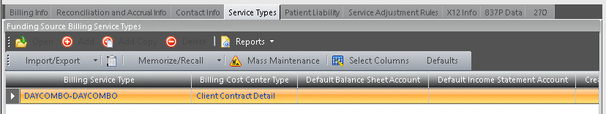
- Go to the Contract Codes tab and Open the Contract Code.

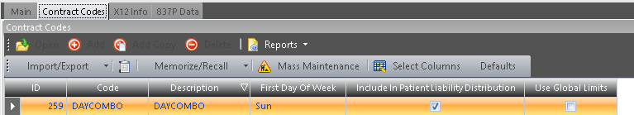
- Go to the Bill Codes Tab and Open the bill code.
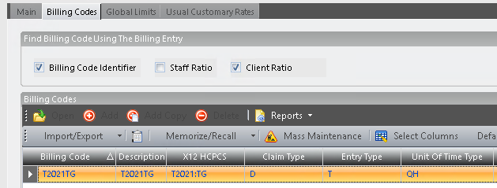
  - Note: If you do not see the ‘X12 HCPCS’ column in ProviderPro when looking at the list of Bill Codes within a Contract Code, we recommend turning this on as it can make finding the correct Billing Codes with the corresponding HCPCS information much easier.
To do this, click ‘Select Columns’ then scroll down to X12 HCPCS, select it and click OK.
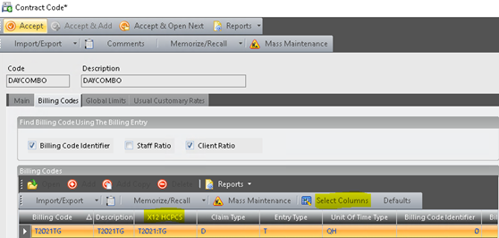
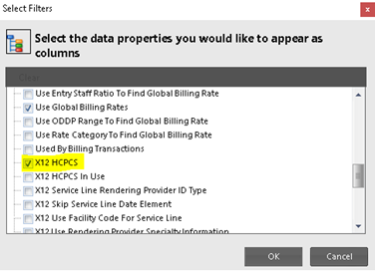

- Go to the Global Billing Rates Tab and Open the previous Global Billing Rate.
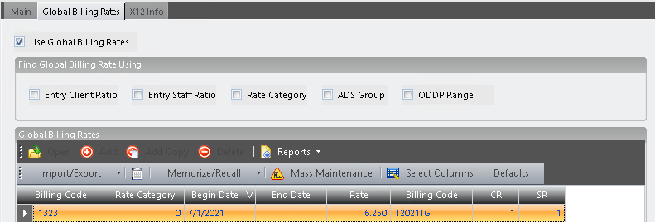

- End date the current/existing Global Billing Rate with the appropriate date, then Click Accept.
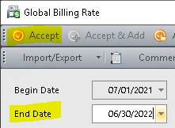
- Click Add to add a new Global Billing Rate.
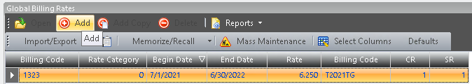
- Enter the Begin Date and newly updated rate, then Click Accept. You will leave the end date blank until needing to update rates again in the future.
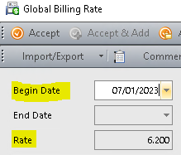

  - Using the updated Rate Comparison Summary, you will find this code (In this example T2021:TG) and utilize the FY24 RATE MODEL column in green. The rate for T2021:TG is $6.20.
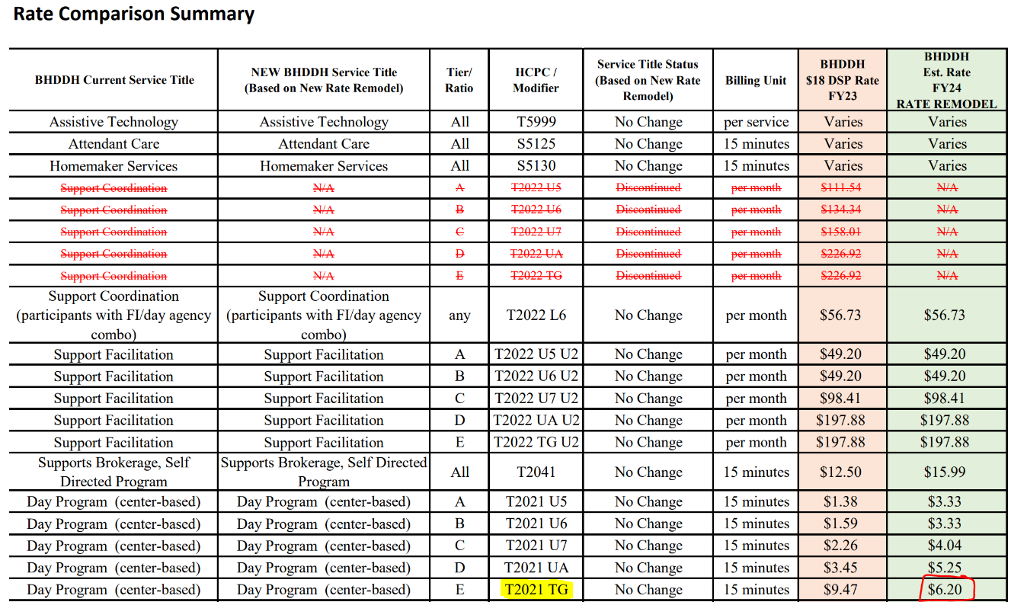

- Accept the popup screens (Bill Code, Contract Code, Billing Service Type) all the way back to the listing of Billing Service Types and Click Save on the top tool bar to fully save your changes.
  - We also recommend Acceipting & Saving after each Billing Service Type or Contract Code.
Accepting & Saving often ensures that if the user making the changes closes the screen without saving, minimal information will be lost/re-entered.

