

July 27, 2023
Sandata Technologies, LLC
sandata.com

Communications Plan – Sandata Mobile Connect App

1. Overview 2
2. Change Management Principles 3
3. Outreach Topics & Activities 4
4. Delivery Methods 5
Appendix A: Communication Templates 5
Letter to Caregivers 5
Sandata Mobile Connect Transition Guide 6
Newsletter Articles 7
Reminder Emails 8
Caregiver Flyers 9

Overview
The new Sandata Mobile Connect app was released to the public in July 2023 through the Apple Store and Google Play. Using feedback regarding areas of improvement for the original Sandata Mobile Connect app (now the Sandata Mobile app), the new app is an upgrade with new features designed to enhance the user experience in multiple ways as well as elevating the look and design of the app.

The original app will remain available in the app store until June 2024 to allow for a smooth transition between apps for States, Agencies, and Caregivers.

This document includes sample communications that the State or Agency may use to communicate the change to caregivers on their own established timelines. Sandata recommends moving to the new app as soon as feasible.

Additional documents may become available through Sandata On-Demand through the change process. If you have any questions, please reach out to your system administrator or your Customer Support Manager.

Change Management Principles
Implementing a new app can be a transformative process. This guide is designed to assist you in effectively managing the change associated with adopting the new Sandata Mobile Connect app.

1. Develop a Cross-Functional Team:
Create a diverse team consisting of representatives from different departments to understand the needs of your stakeholders in adopting the new app. This team will be responsible for the successful rollout of the new app. Their role will be to provide feedback, gather requirements, advocate for the app, and act as ambassadors during the change process.

2. Establish Clear Objectives:
Set specific, measurable, achievable, relevant, and time-bound (SMART) objectives for the adoption of the new app, including a date by which all caregivers should be using the new app. Clearly communicate these objectives to all stakeholders, ensuring alignment with the organization's overall goals.

3. Plan and Prepare:
Develop a comprehensive implementation plan that outlines the steps, timeline, and responsibilities for each phase of the adoption process. Prepare for potential challenges and risks and have contingency plans in place.

4. Communicate Effectively:
Effective communication is vital throughout the change management process. Keep all stakeholders informed about the app's adoption, its benefits, and the timeline. Address any concerns or resistance proactively. Use various channels such as emails, meetings, workshops, and presentations to reach different audiences. Sandata has created various resources to assist with this piece of the transition to the new Sandata Mobile Connect app. Resources can be accessed through Sandata On-Demand.

5. Provide Training and Support:
Sandata has created training documents for the new Sandata Mobile Connect app features and will continue to update training documents for existing features. Additional training may be available at the state’s request. Please speak to your Customer Support Manager about your specific needs.

6. Monitor and Evaluate:
Monitor usage, user satisfaction, and any improvements in productivity or efficiency. Regularly review progress against the established objectives and make adjustments as needed.

7. Continuously Improve:
Serve as a link between the caregivers using the app and Sandata to gather insights and ideas for improving the app and its implementation. Encourage users to provide suggestions and incorporate valuable feedback into future updates or versions.

Effectively adopting a new app requires careful planning, open communication, and a willingness to address challenges proactively. By following this change management guide, you can foster a positive environment for app adoption and empower employees to embrace the new technology to drive business success. Remember that change is a continuous process, and learning from each implementation will enhance future initiatives.

2. Outreach
Successful stakeholder engagement includes communicating early and often to clearly convey the “who, what, why, when, and how” of the app changeover.

Sandata Recommendations:
- Be cognizant of reading level or any ADA requirements the department has followed with other communications.
- Limit the volume of written communications sent to providers. Consider newsletters and stakeholder town halls for variety.
- Keep emails short and purpose focused, highlighting the benefits of the information for the user, and directing readers to the most current source of information.

Outreach Topics & Activities
The following communications are suggested for the app changeover. States and Agencies may use them at their discretion and on their internal established timelines. As with any project, there could be additional ad hoc communications that need to be added to this list to communicate information to stakeholders.

Samples of suggested outreach are available at the end of this document.

Sandata’s Recommendations for Outreach Activity:

 | Outreach Topic & Activity | Topic Description
 | Letter to Caregivers | Outlines the change from the original Sandata Mobile Connect app to the new Sandata Mobile Connect app
 | Sandata Mobile Connect Transition Guide | A quick reference document with answers to basic questions your caregivers may have about switching to the new app
 | Newsletter Articles | Sample articles than can be used through State/Agency newsletters
 | Reminder Emails | Email templates for reminding caregivers to make the change to the new app. Multiple versions are provided.  Sandata recommends sending out reminder emails at a regular cadence based on the timeline to adoption established by the State/Agency.
 | Caregiver Flyers | Available in the top five Sandata Mobile Connect-used languages, these documents describe the benefits of the new app and encourage downloading the new Sandata Mobile Connect app.

4. Delivery Methods
Using a variety of methods can help the State/Agency avoid outreach overload. Too many emails can negatively affect provider engagement. The table below offers several options that the State/Agency can employ to capture interest and keep providers engaged, ensuring they receive important information. For each delivery method, it is helpful to document the owner and necessary lead time.

Sandata Recommendation:
- If using social media, it is strongly recommended someone monitors and manages responses in a timely manner.

Tactic | Description
Outbound Email | Email distribution list containing the email addresses of providers.
Listserv(s) | An application that distributes messages to subscribers on an electronic mailing list.
Social Media | Twitter, Facebook, and other communication forums that are monitored and managed.
Newsletter(s) | Provider associations or other membership newsletters
Website | A section dedicated to the app changeover on State’s existing website, posting all communications, important dates, specifications, timeline, etc.

Appendix A: Communication Templates
Below are example templates for common outreach and communication activities performed as part of the transition to the new Sandata Mobile Connect app.

Letter to Caregivers
[Date]

At [Provider Name], we are committed to providing you with the best tools and resources to meet the needs of your clients through our partnership with Sandata Technologies. As part of this ongoing commitment, we are thrilled to announce the launch of a new Sandata Mobile Connect app.

Sandata has listened to customer feedback and has worked tirelessly to improve your app experience. The new Sandata Mobile Connect app comes with a host of exciting features that will transform the way you work:

- Improved Sign-On: Use a single username and password to access all visits across multiple agencies.
- Better Offline Functions: Continue to input visit information when your signal drops.
- Password Control: Update your password directly from your email.

[Provider Name] will require all caregivers to download the new Sandata Mobile Connect app no later than [insert transition date]. You can download the new app from your system’s app store at any point before that date.

For iOS users: https://apps.apple.com/us/app/sandata-mobile-connect/id6451209985
For Android users: https://play.google.com/store/apps/details?id=com.sandata.smc.prod

We understand that change can be hard, but we are confident that the new app will better meet your needs while continuing to ensure our compliance with the 21st Century Cures Act. We are here to support you throughout this transition and ensure a smooth experience.

If you have any questions or encounter any issues during the download or installation process, our dedicated support team is ready to assist. Feel free to reach out to them at [Provider Support Email/Phone].

Thank you for being an integral part of [Provider Name],

[Your Name]
[Your Title/Position]
[Provider Name]
[Contact Information]

Sandata Mobile Connect Transition Guide
Please visit Sandata On-Demand for the most up-to-date version of this document. Additional information may be needed as appropriate. A Word document is available for download on the Sandata On-Demand site.

Sandata Mobile Connect Transition Guide

Newsletter Articles

Sample Newsletter Announcing App
New Sandata Mobile Connect App Coming

Your EVV experience is about to get better! In July, a new Sandata Mobile Connect (SMC) app will launch in the App Store and Google Play.

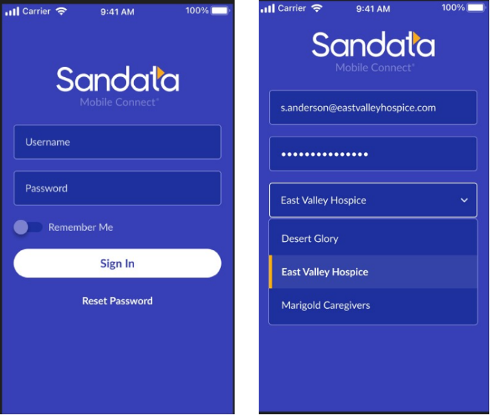

This new app will help make EVV more efficient by focusing on the user experience and includes new features, like:
- Improved log in with a single username and password for all your agency accounts.
- Better offline performance when service is disrupted.
- Prompts to help you collect the information you need without mistakes.

Watch your email, Sandata On-Demand, and future newsletters for more information on this new app and for tools and tips on how to move your caregivers to the new SMC as easily as possible!

Sample Newsletter Discussing Simplified Sign-On
Sandata Mobile Connect Introduces Simplified Sign-On
The new and improved Sandata Mobile Connect (SMC) app introduces features like Simplified Sign-On that are guaranteed to help you have a smoother Electronic Visit Verification (EVV) experience.

With Simplified Sign-On, caregivers only need a single set of credentials to log in to their agency accounts. During log-in, the caregiver may select the visit agency from a drop-down menu instead of logging in with a separate username or password for each agency.

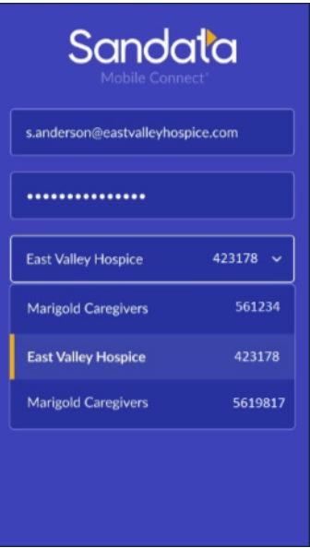
Watch your email, Sandata On-Demand, and next month’s newsletter for more information on new features and how you can utilize them to make the most of SMC!

Reminder Emails

Version #1 – Short Version
This is a reminder to download the Sandata Mobile Connect app through the Apple Store or Google Play store.

[Insert State]’s Electronic Visit Verification (EVV) program is serviced by the Sandata Mobile Connect app. [Insert any information about a state deadline to move to new app, if applicable.]

Version #2 – Medium Version
Make your workday easier – download the new Sandata Mobile Connect (SMC) app now!
With a range of exciting new features right at your fingertips, the new SMC streamlines your work, letting you log in more easily, change your password through email, and guides you to the next step in the visit.
We’ve taken the “work” out of the app, letting you focus on your work with your client.
Don't miss out on these benefits! Download the app now.

For iOS users: https://apps.apple.com/us/app/sandata-mobile-connect/id6451209985
For Android users: https://play.google.com/store/apps/details?id=com.sandata.smc.prod

Version #3 – Long Version
We are excited to introduce you to the new Sandata Mobile Connect app, making your work more efficient and your professional life easier!

Download the app today from your app store to get started. The Sandata Mobile Connect app improves your user experience by:
- Giving you an improved log-in process – one username and password to access all your visits!
- Letting you continue to enter visit information if the signal drops.
- Resetting your password without an administrator
Downloading the app is simple and will only take a few minutes:
For iOS users: https://apps.apple.com/us/app/sandata-mobile-connect/id6451209985
For Android users: https://play.google.com/store/apps/details?id=com.sandata.smc.prod

We are confident that the new app will provide an improvement in your daily work, allowing you to focus on what truly matters – the care of your clients.

If you encounter any issues during the installation process or have any questions about the app's functionalities, feel free to reach out to our dedicated support team at [Program Support Email/Phone].

We encourage all users to download and begin using the new Sandata Mobile Connect app no later than [insert go-live date for program].

Caregiver Flyers

Please visit Sandata On-Demand to download the available Caregiver Flyers.

Currently flyers are available in the following languages:
English
Spanish
Chinese (Mandarin)
Chinese (Cantonese)
Russian
Somali

