Sandata Mobile Connect Introduces Simplified Sign-On
The new and improved Sandata Mobile Connect (SMC) app introduces features like Simplified Sign-On that are guaranteed to help you have a smoother Electronic Visit Verification (EVV) experience.
With Simplified Sign-On, caregivers only need a single set of credentials to log in to their agency accounts. During log-in, the caregiver may select the visit agency from a drop-down menu instead of logging in with a separate username or password for each agency.

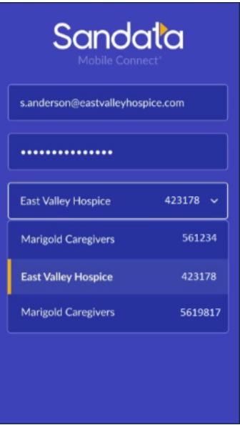
Watch your email, Sandata On-Demand, and next month’s newsletter for more information on new features and how you can utilize them to make the most of SMC!
If you have not downloaded the new app yet, you can do so by visiting the Apple Store or Google Play Store.

