New Sandata Mobile Connect App Coming

Your EVV experience is about to get better! A new Sandata Mobile Connect (SMC) app has launched in the App Store and Google Play.

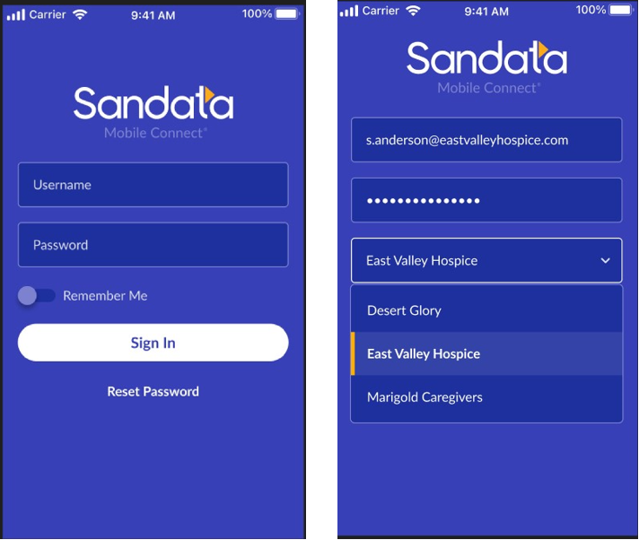

This new app will help make EVV more efficient by focusing on the user experience and includes new features, like:
- Improved log in with a single username and password for all your agency accounts.
- Better offline performance when service is disrupted.
- Prompts to help you collect the information you need without mistakes.

Watch your email, Sandata On-Demand, and future newsletters for more information on this new app and for tools and tips on how to move your caregivers to the new SMC as easily as possible!

