

On-Premise to Citrix Virtual Environment Project Worksheet
Customer Information
Customer Name:
Customer IFS Contacts Code:

Customer Contact Information
Name:
Email Address:
Phone Number:

Technical Contact Information
This contact will assist with backing up the ProviderPro database & sending it to Sandata.
Name:
Email Address:
Phone Number:

Citrix Folder
Sandata can create folders that are available to an organization while the user is in Citrix. These folders can be accessible by all users at an organization or restricted to those you list here. This can be changed at any time you would like, and use is completely optional. Example: Some organizations will create a payroll folder that is only accessible to those in their Payroll Department.
Will you require Citrix Folder(s)? (Y\N)
If yes, please list the name of the folder & users who should have access to each. If there is more than one user per folder, please list each separated by commas.
Folder Name | User(s)
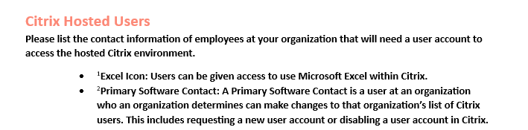

First Name | Last Name | Email Address | Title | ¹Excel Icon (Y/N) | ²Primary Software Contact (Y/N)

