

Manually Adding Clients to Sandata EVV
Job Aid

  - Massachusetts EOHHS

December 13, 2024

Manually Adding a Client to Sandata EVV
If a client does not appear in Client Management in Sandata EVV, you may need to manually add them. Clients with authorizations are automatically brought over into Sandata’s system.

1. Go to the Client module in Sandata EVV. Make sure the client is not in your account by searching Pending clients. Select Filters, then select Pending to show clients you have not activated.
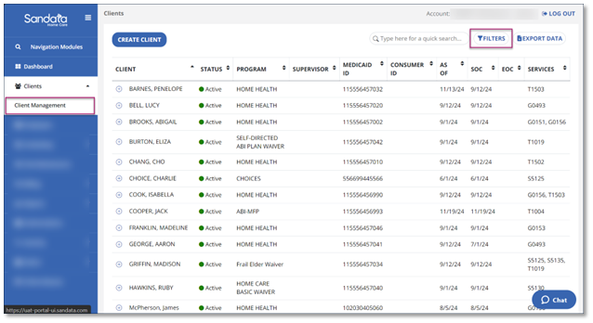
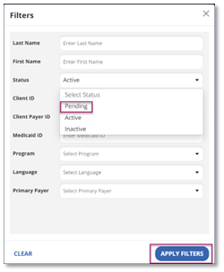
2. If the client is not there, that means they do not have an authorization attached and will need to be manually added. Select Create Client.
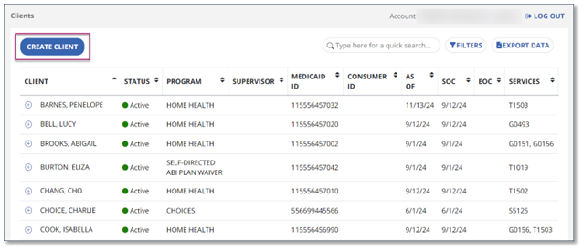
3. Enter the Date of Birth, Medicaid ID, or Consumer ID of the client and select Search. If a match is present, the client will appear. Select Create Client to add the client.
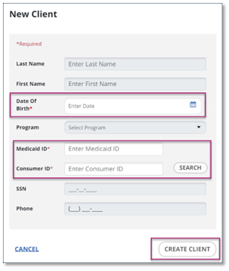

4. Go to the Visit Maintenance module if your employees have captured visit data for this client. You will notice unverified visits with a red dot exception indicator in the Client column. This means the visit was completed without identifying the client. Use the Filters feature to find incomplete visits with this exception type in the date range you need to update.
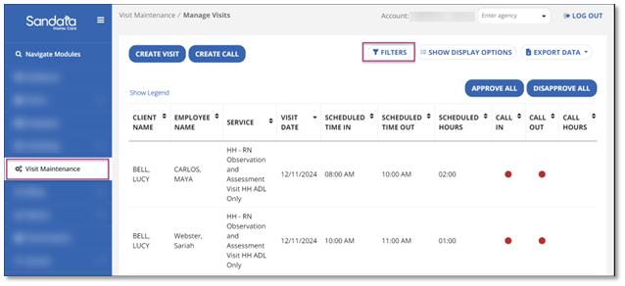
5. Fix the exception by identifying the client you added.

For more information on how to manage your visits, complete training in Sandata Learn or review guides on Visit Maintenance at Sandata On-Demand.

