Learning Management System (LMS)
Registration for Provider Agencies
Quick Reference Guide for
Agency Administrators Under CalEVV

To sign up for and take training in the LMS, please follow the steps below:

- Open a web browser (Google Chrome, Mozilla Firefox, or Microsoft Edge) on your computer.
- Type the enrollment URL below in the browser address bar, copy and paste it into the browser bar or click the link: https://www.sandatalearn.com/?KeyName=CAvendoradmin
- Complete the fields in the Sign-Up section of the screen
  - First Name
  - Last Name
  - Email address
  - Password (must be at least 8 characters long and include at least one number)
  - Agency Name
  - CalEVV Identifier (received via email just after self-registration)

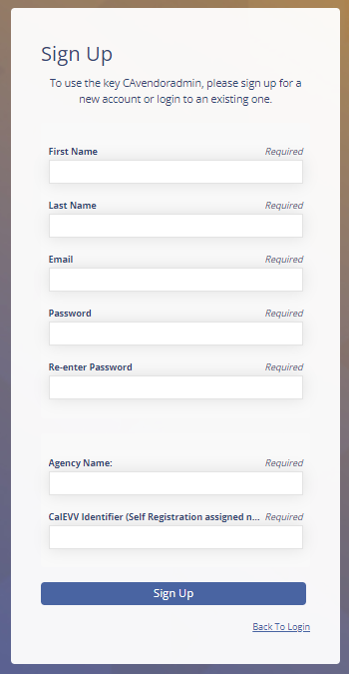

- Click the Sign-Up button.
- The Sandatalearn homepage will display.

- Click on My Courses to view the available course.

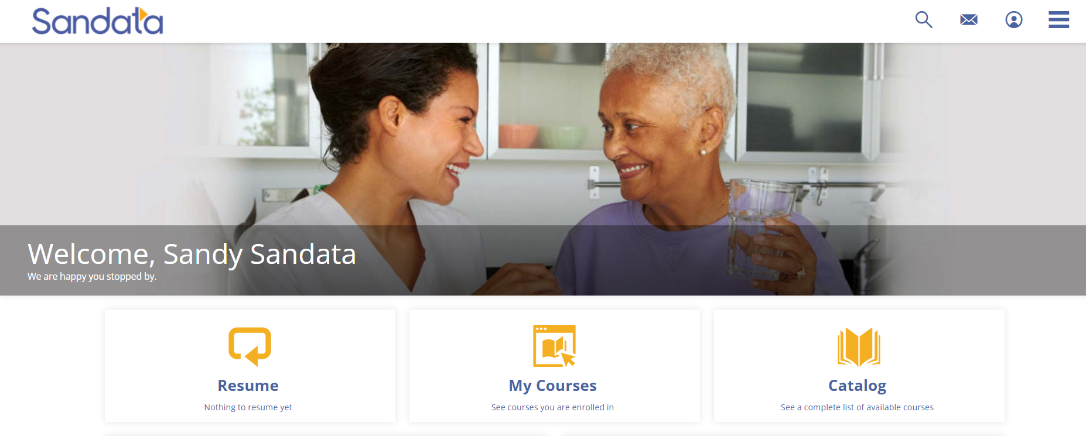

- Click the CA folder to open the folder and see the CalEVV training courses.

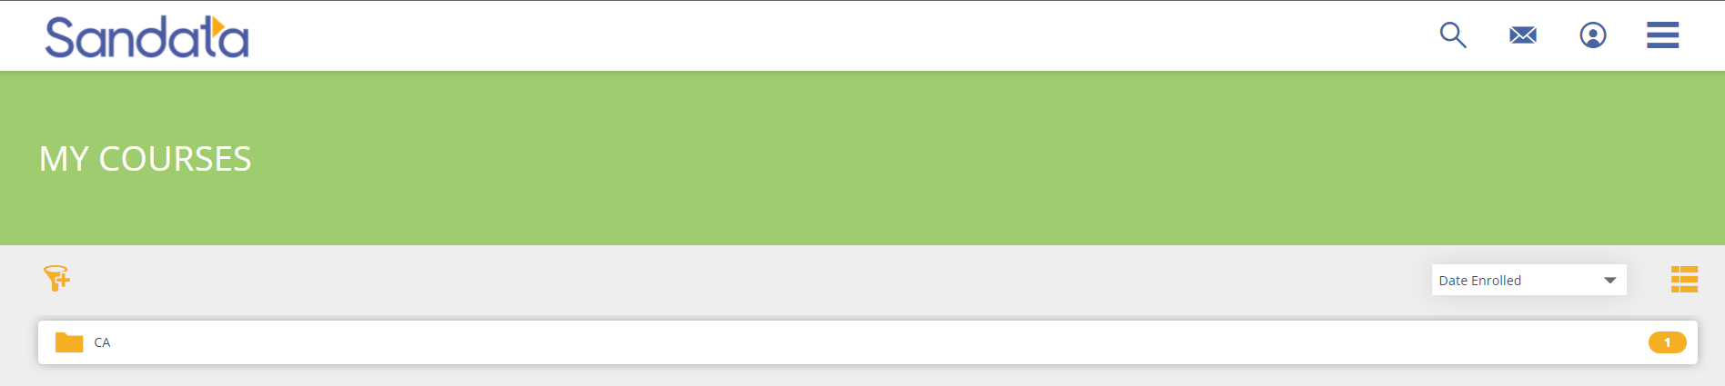

- Click the course name or the Start button to open the course.

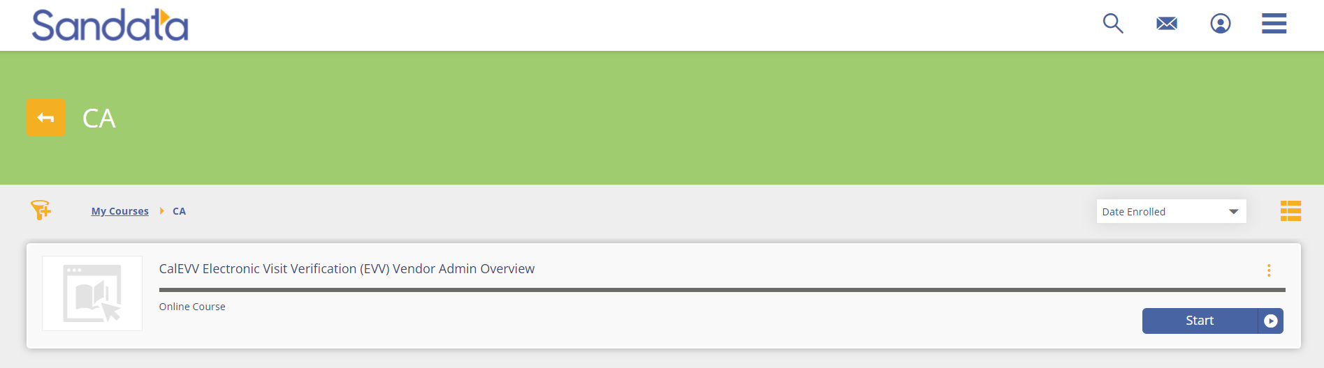

- Click the Start button to start the session. (*Note: Sessions must be completed in order. When one session is completed, the next session is unlocked for review.)

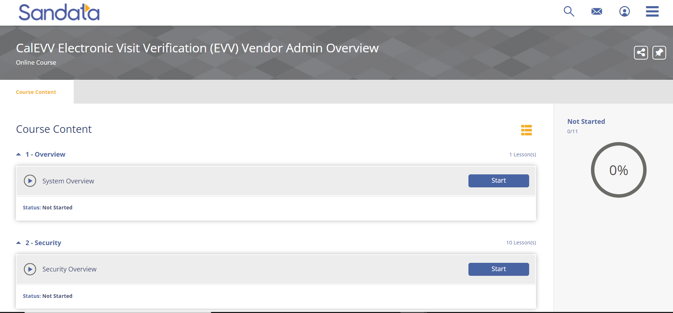
Upon completion, the lesson progress will show a status of “COMPLETED”

- To access the completion certificate, click on the menu bar in the upper-right corner of the screen and choose the Transcript option.

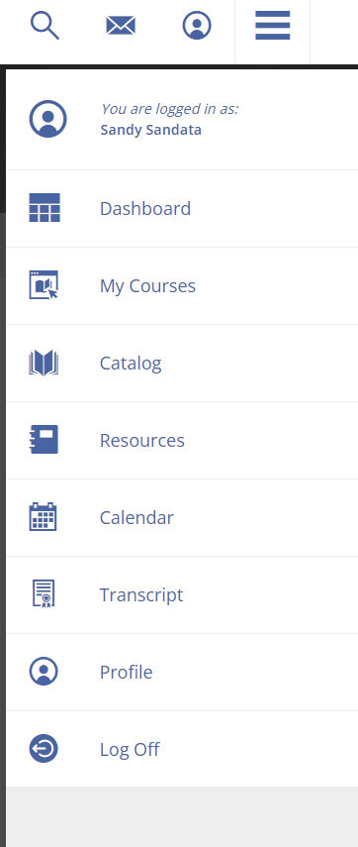
You may log in to Sandata Learn at any time to review course materials by going to: https://sandatalearn.com and entering your login and password.

