Learning Management System (LMS)
Registration for Independent Providers
Quick Reference Guide

To sign up for and take training in the LMS, please follow the steps below:

- Open a web browser (Google Chrome, Mozilla Firefox, or Microsoft Edge) on your computer.
- Type the enrollment URL below in the browser address bar, copy and paste it in the address bar or click on the link: https://www.sandatalearn.com?KeyName=CAindependent
- Complete the fields in the Sign-Up section of the screen
  - First Name
  - Last Name
  - Email Address
  - Password (must be at least 8 characters long and include at least one number)
  - CalEVV Identifier (received via email just after self-registration)

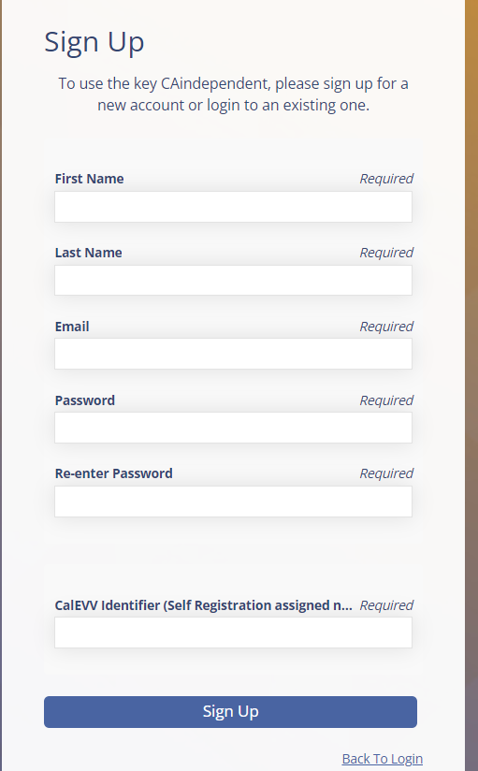

- Click the Sign-Up button.
- The Sandatalearn homepage will display.
- Click on My Courses to view the available course.
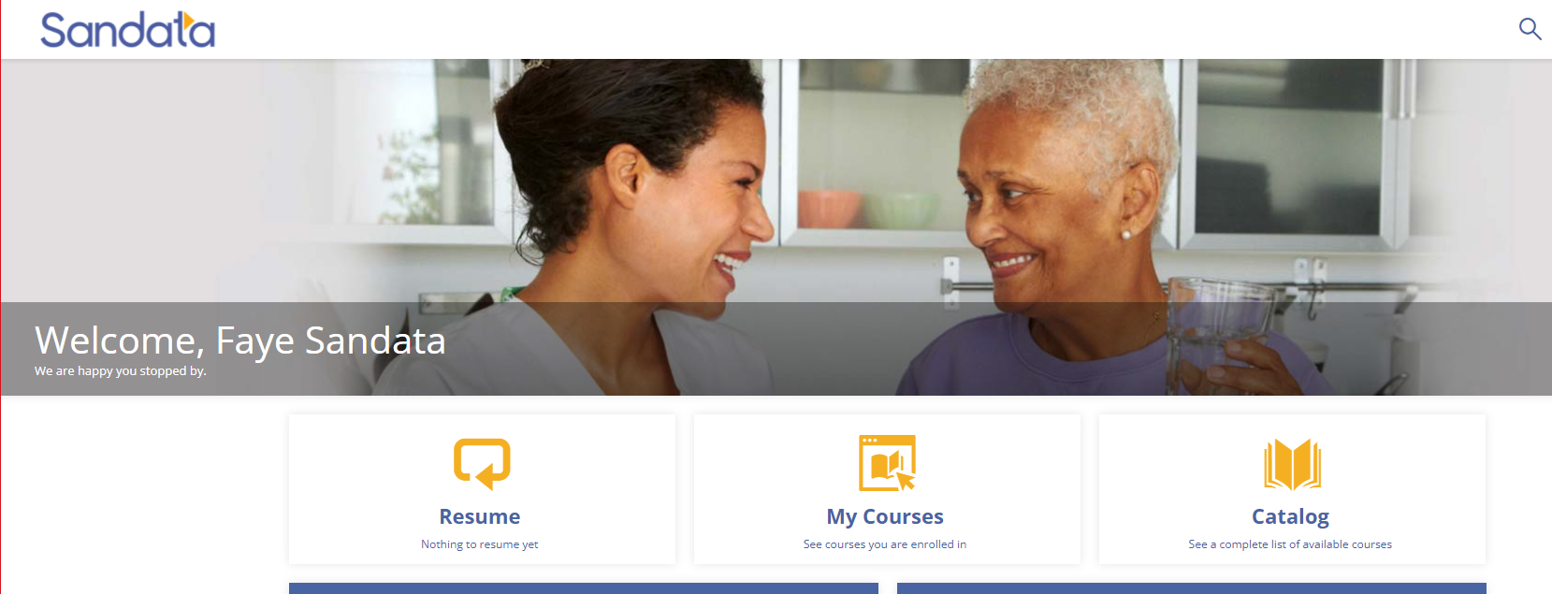

- Click the CA folder to open to the course.

- Click the course name or the Start button to open the course.

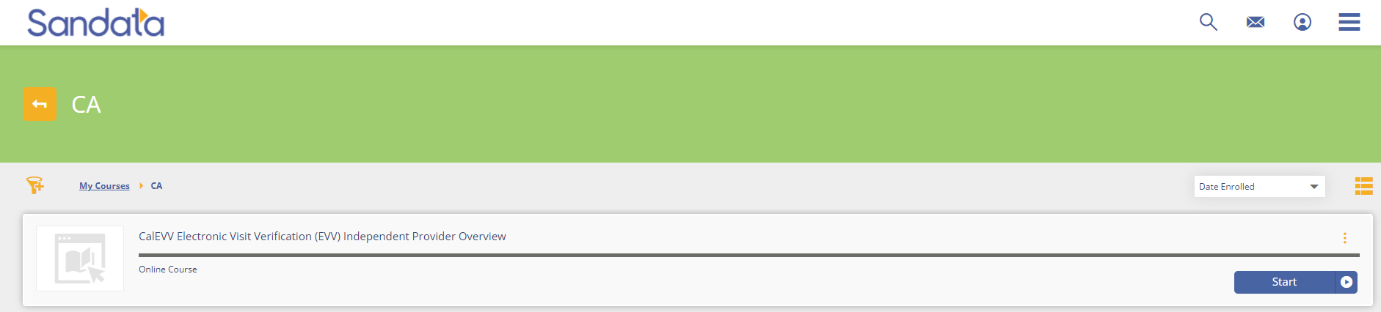

- Click the Start button to start the session. (*Note: Sessions must be completed in order. When one session is completed, the next session is unlocked for review.)
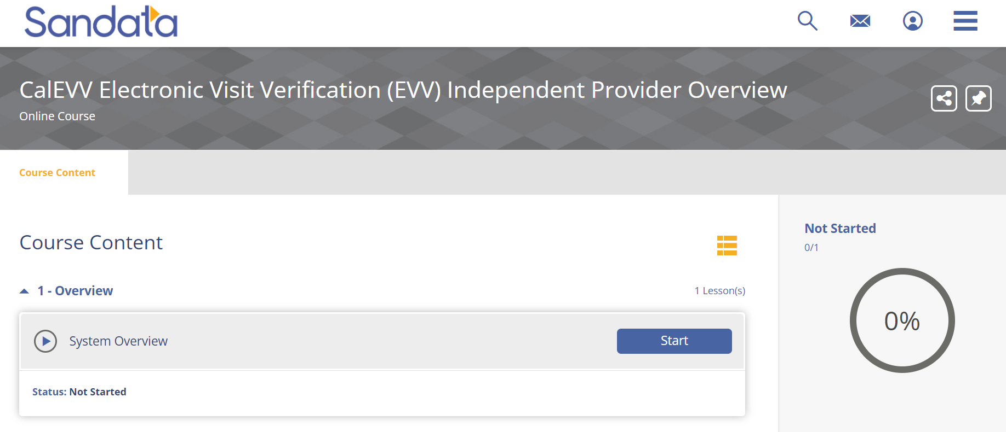
Upon completion, the lesson progress will show a status of “COMPLETED”

- To access the completion certificate, click on the menu bar in the upper-right corner of the screen and choose the Transcript option.

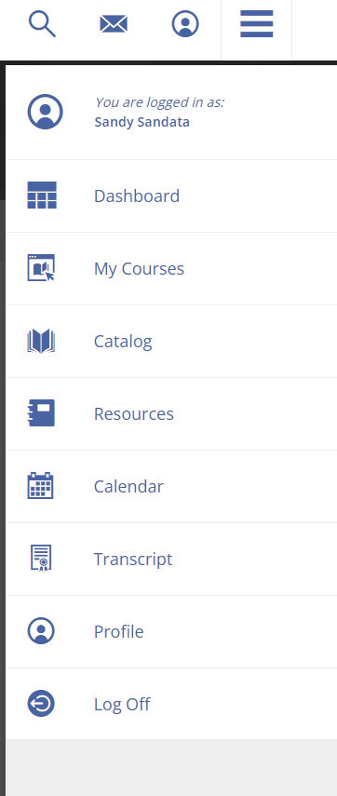
You may log in to Sandata Learn at any time to review course materials by going to: https://sandatalearn.com and entering your login and password.

